Bournemouth, Christchurch and Poole and Dorset Safeguarding Adults Boards
Multi-Agency Risk Management
Principles and Guidance

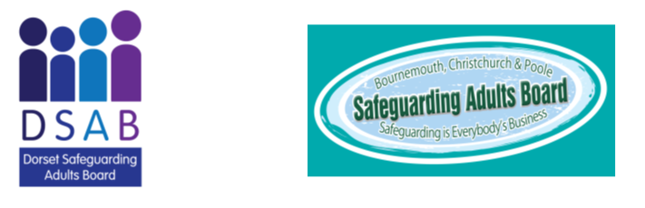

Contents
Introduction 3
Definition and criteria 3
Key operational principles 4
Which agency leads 6
Multi-agency working and the MARM 6
About the meeting 6
Concluding the MARM 8
Mental capacity (including assessing capacity) 8
Information sharing – the key concerns 8
Appendix 1. Flowchart 11
Appendix 2. MARM meeting agenda and template form 12
Appendix 3. Other meetings 17

Introduction

This Guidance about Multi-agency Risk Management (MARM) originates in the good practice which enables agencies to share information where there are concerns about an individual living in the community. This may include someone in a care home if there are several agencies involved supporting the individual. The MARM would be used as a mechanism to bring all parties together. The agencies can use the Guidance and the meeting template to formulate responses and explore solutions quickly. Any agency can convene a MARM meeting and there are a wide range of circumstances when this might be appropriate, to respond to the situations and circumstances set out in the Definitions and Criteria below.

A MARM is not a substitute for a Safeguarding Adults Enquiry (section 42 (2)) Since the removal of the “non-statutory” safeguarding category from the Safeguarding Adults Statutory Guidance the local authorities use case management to respond to those type of concerns. In many such circumstances they are likely to convene a MARM.

A MARM may be a single event or, because of the often protracted nature of the challenges, a series of meetings. It can be used to support individuals to improve their wellbeing as well as understanding and responding to, or mitigate, the risks and challenges they face. In MARM meetings agencies can meet with the person, their carer and/ or their advocate, using the Guidance to identify and share risk, whilst maximising the opportunities for developing resilience and drawing on the strengths of the community for support.
This Guidance stands alone but links to the BCP and Dorset Council multi-agency Safeguarding Adults Procedures. Specific links are in Appendices 2 and 8 of the Procedures and within the self-neglect and hoarding guidance published by the Safeguarding Adults Boards:

Definition and criteria

MARM is used to refer just to a meeting but several arrangements need to be made for this to be successful. These are fully explained here and include the involvement of the person.
MARM meetings are one of several options for discussion about concerns, the level of risk and challenges for people being worked with or known to public agencies. Other options are summarised in Appendix 3.
MARMs have no statutory basis but are governed by requirements to show due diligence, care and responsibility to deliver safe outcomes and mitigate risks for people in need.
The decision to hold a MARM meeting should be considered by any agency working with or with knowledge of people experiencing a high or unmanageable level of risk because of circumstances which create the risk of harm to themselves or others. If there is potential that the harm or neglect may be caused by others an initial discussion with the LA safeguarding team should be had and an agreement made to hold a MARM, or other actions agreed. Referrals will only be made to the LA safeguarding team if the MARM process has not been able to resolve the issue.

Criteria for holding a MARM
One or more of the following criteria can apply:
- Factors placing the person at a higher risk of abuse or neglect, including mate crime, network abuse or other factors which could lead to harm or exploitation.
- Self-neglect including hoarding and fire safety.
- Refusal of or disengagement from care and support services.
- Complex or diverse needs which either fall between, or span, several agencies’ statutory responsibilities or eligibility criteria.
- On-going needs or behaviours leading to lifestyle choices placing the person and/or others at significant risk.
- Complex needs and behaviours leading the person to cause harm to others.
- Impact of domestic violence, mental health and substance misuse.
- Risks previously addressed via a section 42 enquiry but the need for ongoing risk management and monitoring has been identified.
- Risks which are anticipated to increase in intensity and where it would be valuable to monitor, review and coordinate support for a person.

Key operational principles
These principles are set alongside the standards required for holding a MARM meeting.
- Clarity of purpose.
Each agency will make a record of the reason for the MARM being called.
All agencies should use their own IT recording systems to record the reason for convening a MARM, as well as on the MARM template form for use by all agencies which is included at Appendix 2.

- Governance
MARM meetings will be chaired by a staff member in an operational supervisory grade post or, where necessary, delegated by the post holder. The Chair of MARM meetings has overall responsibility for ensuring compliance with all aspects of this Guidance. As the default completion of all sections of the MARM template is required. Where this is not thought necessary or possible the reason should be recorded.
In the event of dispute about issues or actions considered at a MARM it may be useful to refer to Appendix 21 of the Multi-agency Safeguarding Adults Procedures which deals with resolution of conflicts.

- Making Safeguarding Personal.
The MARM process must involve the person in discussion about holding a meeting, agreeing their participation and/ or representation (whether attending or not), having their views considered and to receive feedback from the meeting and to provide further comment afterwards.

Note: it may be that a person will want to attend only part of the meeting. It must remain person centred and transparent. The MARM meeting can still be held without the person present providing this is agreed and a record made explaining why.

Depending on the circumstances a MARM meeting may also be held where the person lacks mental capacity to understand and talk about the concerns. However, their interests can be represented either by someone close to them or an advocate. See Appendix 3

- Accountability
Will be shown by completing an accurate written record against each item on the meeting template, including actions specifying the responsible person and a timescale. The Chair is responsible for the agreed actions of the MARM meeting, delegating as appropriate. additional notes are acceptable if they are needed to capture points not on the template.
If actions set at the MARM are not carried out it needs to be evident this was justified so the reason must be recorded and escalated if necessary.
If the situation which is causing concerns at a MARM is not resolving or continues to be unstable the Chair will need to consider other actions for resolution. This may result in further discussion with the agency safeguarding lead or the LA safeguarding team.

Which agency leads
It is expected that the agency which is working most closely with the person, or the person who has made the MARM referral, will be the one which convenes the meeting and leads the process. Unless agreed otherwise the decision to convene a meeting will also mean responsibility for hosting and facilitating it. The agency which has chaired the meeting will be responsible for making sure there is a key point of contact appointed for communication between the organisations and the person at the centre of the MARM. This does not necessarily need to be from their own agency. The lead agency will also be responsible for allocating the actions agreed in the meeting.

Multi-agency working and the MARM
Because the MARM relates to community based (rather than care homes or hospitals) concerns it may often be appropriate for the Fire and Rescue Service, Police, housing agency, substance misuse service, probation services, or Environmental Health to convene it, not just the local authority or health services.

All agencies are dedicated to preventing harm but it is understood that resources are limited and attendance for some agencies: e.g., the Ambulance Service may not always be realistic. The agency convening the meeting needs to think carefully about who to invite and if a report could be provided instead.

About the meeting

Before the meeting:
- A clear explanation of the specific reason(s) for convening the MARM, the perceived risks and whether convening a MARM is a proportionate way to respond.
- The appointment of a Chair
- Appointment of a notetaker
- Agreement about responsibility for drafting notes, issuing them for any amendments and then distributing the final version.
- Venue and time, bearing in mind the importance of a location and time that enables the person to attend. Always consider the option of a virtual meeting.
- An agenda; this will usually follow the MARM meeting template.
- Invitations should clearly state what the reason is for convening the meeting.
- If any relevant agencies are not available ensure they are asked to provide a report.
- Engage with the individual who will be subject of the meeting as set out above unless there is sufficient risk or reason for them not to be made aware of the meeting. If so that decision and the rationale must be recorded.

The meeting and its outcomes:

- Ensure the template is used throughout. If any sections are not relevant the reason for this needs to be recorded on the form.
- Sharing the information each has or agree what still needs to be collected.
- Consider the current risk assessment or decide about the need for one, particularly if information is still lacking. A risk assessment in an agreed format can support this requirement.
- The perspective of the individual, their insights about their situation, views, wishes, expectations and engagement.
- Insight about whether the individual has the mental capacity to appreciate the risks posed to themselves and others.
- Insight about whether behaviour is eccentric and whether the individual can control that behaviour.
- Key others who might need to be involved are relatives, formal carers, informal carers or an advocate for people who are not capacitated.
- Development of a risk management plan including monitoring and further review.
- Make sure there is accurate recording and that defensible decision making is evident.
- Identify the most appropriate agency/ individual staff to stay involved and engaged in co-ordinating the ongoing management of the individual’s risk management plan. This person will also be the main link for communication, whether urgent or more routine.
- Ensure all actions have an owner, a timescale for delivery and that there is a review date, monitoring and/ or other outcomes.
- Undertaking any outstanding risk assessments/ information gathering.
- Agree a contingency plan which includes an understanding of “trigger” points that will lead to reconvening of the MARM or referral elsewhere e.g. to be considered by the local Safeguarding Team.
- Feedback to the person concerned (if she/ he is not present) and obtain their views about the outcomes and review what needs to change in the light of this.
.
In general terms members of MARM meetings must appreciate they have the same authority and responsibility to obtain support in difficult or complex circumstances as if the matter was being dealt with via a Section 42 Enquiry or because of any other case-based concerns / issues.

This might include getting legal advice about the Court of Protection, talking with colleagues in domestic abuse services or considering mental capacity or a best interest decision if there is sufficient doubt about whether a person can make decisions about the risks or concerns that led to the meeting.

A formal best interests meeting is likely because decisions facing the person are complex and cannot be easily made by the decision-maker and immediate colleagues. It is separate from the MARM meeting but they can work in tandem. See Appendix 3 and the section below on mental capacity.

Concluding the MARM

Ideally work will be carried out with the individuals which will result in their situation being improved and considered safe enough to conclude agency involvement. This will be based on decisions made with the individual, their families/carers (if appropriate) and agencies involved. The decision to close a period of activity will be recorded by every agency party to the MARM, highlighting any monitoring that will remain in place. It should be clear that future concerns can be considered as or when necessary.

Mental capacity (including assessing capacity)

The nature of any involvement centres on whether the person concerned has the mental capacity to make decisions that have legal force. A person may have mental capacity and yet disagree with the views of the professional. This is a right that cannot be taken away from a person who has mental capacity. It does not preclude the professional from talking to the person to explore the area of concern.

Involvement and the offer of support does not depend on a request by the person or anybody else and is not negated by a third party’s refusal to grant access to the person, or their refusal to participate. A person’s right to make apparently unwise decisions which have risks and to refuse support should be respected.
An assessment of the person’s mental capacity also means considering their executive function as well as their ability to understand e.g., in practice can they manage any risks and safety implications of the choice or decision being made. In other words, the person should consider: “Do I understand the limits of my own ability and the risks and safety implications of the choice or decision being made”?

The issue of an individual’s capacity to understand the risks and dangers they may be faced with will, in certain cases, mean thinking about whether the Mental Capacity Act 2005 (MCA) applies.

It is important to record an assessment of capacity when there has been a doubt expressed about an individual’s understanding. This will include a view about whether an individual’s capacity fluctuates. If this is felt to be the case, it may well influence the timing about when it’s best to work with a person
Further details about the Mental Capacity Act are at Appendix 16 of the Safeguarding Adults Procedures.

Information sharing – the key concerns
The Data Protection Act (2018) requires agencies to make sure personal information is processed lawfully and fairly. People have a right to view any information held about them. Practitioners should consider this when they are recording information about a person and although the law and legal guidance provides a framework it will always be necessary to make decisions on a case by case basis. Permission will always be sought from the individual about what health information can be shared with the meeting.
Consent for actions affecting an individual should be always obtained from the person concerned if they have the mental capacity to provide it. There are though situations when information can be shared without consent.
These include -
- circumstances where the information shared can be justified in the public interest,
- the protection of children/adults at risk /the wider public from significant/serious harm,
- promoting the welfare of children or preventing crime and disorder.
When making the decision to share information without consent, the risks and benefits of doing so must be weighed against what might happen if it is not shared. This may require personal professional judgement and the judgement of other organisations involved. Care must be taken to verify the credibility of what is being shared.
If it is decided to share information without consent, an explanation must be given to the person about whom it is going to be shared with and the rationale for this, unless it is inappropriate or unsafe to do so. That may apply when the concern is considered significant enough for a referral to the Safeguarding Adult team under Section 42(1).
Sometimes it will be necessary for an agency or a MARM meeting to consider defensible decision making. A quick check against the following criteria could help:
- Use of reliable assessment methods
- Collecting and evaluating all relevant information
- Adopting a proactive approach with individuals and their wider support network
- Acknowledging a person’s right to be treated as an autonomous individual – including right to make an informed decision and unwise decisions (MCA and in accordance with Code of Practice)
- Clear and accurate recording
- Considering the balance between benefits of intervening and risk of harm by not doing so.
- Ensuring support plans meet assessed need and achieve agreed outcomes identified in persons assessment

Information Sharing is more fully dealt with at Appendix 9 of the Safeguarding Adults Procedures.

Appendix 1. Flowchart

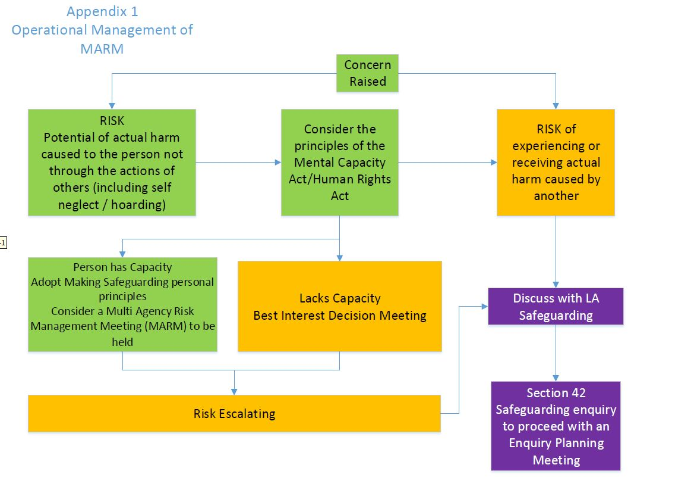

Note: See Guidance for links between MARM and Best Interest meetings.

Appendix 2. MARM meeting agenda and template form
- Confidentiality and Equal Opportunities/Completion of Signing in Sheet (contact details to be provided for distribution of notes). Bear in mind the need for virtual arrangements if needs be.
- Introductions and Apologies.
- Details of the person whose needs are being considered (Name/Date of Birth/Address/GP/Family if known/ NHS no.).
- Purpose of the meeting to be explained and recorded on the meeting template.
- Establish if the person is aware of concerns and if their consent has been gained about meeting. If not known decide how to obtain consent and record as an action. Discuss what action may be taken if consent is not obtained.
- Background to the concerns (including interventions and/or actions already tried).
- Confirm the person’s capacity in relation to the specific decision or the need for an Advocate.
- Relevant Information sharing from each agency.
- Assessment of the risks – agree severity, consider evidence for the risks and outline actions to be taken, by whom and the timescale.
- Identify and agree who is the most appropriate person to talk with the person following the meeting; also, to support and empower them to make any decisions and take agreed actions.
- Agree how the risks will be monitored and by whom. Complete Risk Management Plan and agree timescales for circulation.
- Confirm the lead agency and who will coordinate the necessary actions, receive and distribute information about change in circumstances or new risks, including contingency planning.
- Review: agree a timescale for review of the risks and the situation.
- Risk Management Plan to be updated by relevant individuals/agencies.

Note – the risk management plan is to be completed and attached to the notes of the meeting as a separate document rather than be embedded within the meeting notes.

MULTI AGENCY RISK MANAGEMENT MEETING - TEMPLATE
Person at Risk of Abuse details
Name:
Address:
Date of Birth: |  |  |  |  | Age: |  |  | Gender: Female Male
Person/Identifier: |  |  |  |  |  |  | Date of Referral:
GP details:
NHS no.

Name of lead agency:
Name of Chair: |  |  |  |  |  |  |  |  | Date of Meeting:
Attendees:
1. | Statement of Confidentiality & Equal Opportunities/Completion of Signing in Sheet.
• | These were circulated and read. Signing in Sheet confirms agreement.
Purpose of the meeting

Concerns to be addressed

2. | Introductions:
• | Introductions were made by all those who attended
3. | Establish Consent & Wishes/Desired Outcomes of Person at Risk
4. | Consideration of mental capacity and potential need for advocacy (where there is reason to raise this)
5. | Background/ context of meeting
6. | Relevant information sharing
7. | Identify Risks to be addressed (also refer to risk assessment and management templates at 11. below)
a.
b.
c.
d.
e.
f.
g.
8. | Complete Multi Agency Risk Management plan. A/S Risk Management Plan.
9. | Contingency planning
10. | Review arrangements – date of next meeting/ closure/ onward referral/ other actions to be specified
11. | Risk assessment and management templates

 | Identified risk | Adult’s own view | Factors increasing risk  (to include understanding of when risk might occur) | Factors decreasing risk  (protective factors/adult’s network/resources to manage risk)
1.
2.
3.
4.
5.
6.
7.
8.

Proposed action to minimise risk |  | By whom + timescale
1.
2.
3.
4.
5.
6.

Appendix 3. Other meetings
Best interest meeting
A formal best interest meeting is necessary because decisions facing the person are complex and may not always be easily made by a decision-maker and immediate colleagues.
There may be a range of options and issues that require the considered input of several staff as well as those with a personal and/or legal interest in the needs of the person lacking mental capacity.
A best interest meeting will be needed if there are differing opinions about what is in the person’s best interests and a consensus cannot be reached. This may exist between professionals or other interested parties such as relatives. Making sense of these issues and options can only be properly covered and addressed through holding such a meeting, and clearly recording the discussions.

MARAC/ HRDA
MARAC (Multi-Agency Risk Assessment Conference) the multi-agency forum of organisations that manage high-risk cases of domestic abuse, stalking and ‘honour’- based violence. Used in BCP Council local authority area.

HRDA (High Risk Domestic Abuse) is a multi-agency, whole family focused process where information is shared on the highest risk cases of domestic violence and abuse between different statutory and voluntary sector agencies. HRDA builds on the previously used MARAC (Multi-Agency Risk Assessment Conference) model that continues to operate in BCP and other parts of the UK. HRDA brings together daily practitioner meetings and a monthly management meeting. Used in the Dorset Council area.
See www.dorsetcouncil.gov.uk/hrda

Professionals meeting
Self-evidently a meeting convened between professionals on a single or multi-agency basis. It will need to be explained and recorded why such a meeting is necessary, as opposed to a MARM meeting.
Case discussion
A meeting most likely to be held on a routine supervisory, regular MDT and/ or monitoring basis to review the nature, purpose and direction of engagement in relation to a specific person known to an agency

