Multi-agency Risk Management (MARM) - summary and flowchart
To be read in conjunction with the BCP and Dorset Safeguarding Adults Boards’ Multi-Agency Risk Management Principles and Guidance.
A MARM is not a substitute for a Safeguarding Adults Enquiry (section 42 (2)) Since there is now no “non-statutory” safeguarding category the local authorities use case management to respond to those type of concerns. In many such circumstances they are likely to hold a MARM.
A MARM may be a single event or, if necessary, a series of meetings.
Definition: to be used for people who are experiencing a high or unmanageable level of risk because of risk of harm to themselves or others. When there are allegations of harm by others to be held only if agreed with the local Safeguarding Team there is no conflict with Section 42 (ii) of the Statutory Guidance.
Criteria
- Factors placing the person at a higher risk of abuse or neglect, including mate crime, network abuse or other factors which could lead to harm or exploitation.
- Self-neglect including hoarding and fire safety.
- Refusal of or disengagement from care and support services.
- Complex or diverse needs which either fall between, or span, several agencies’ statutory responsibilities or eligibility criteria.
- On-going needs or behaviours leading to lifestyle choices placing the person and/or others at significant risk.
- Complex needs and behaviours leading the person to cause harm to others.
- Impact of domestic violence, mental health and substance misuse.
- Risks previously addressed via a section 42 enquiry but the need for ongoing risk management and monitoring has been identified.
- Risks which are expected to increase in intensity and therefore it would be valuable to monitor, review and coordinate support for a person.
Principles
- Clarity of purpose: what’s the meeting for. Record on the template
- Governance: chairing by a supervisory grade postholder or by delegation. The Chair of MARM meetings has overall responsibility for compliance with the full Guidance.
- MSP: The need to involve the person in meeting - attending or being represented (if present or not), to receive feedback and provide comments. Note: a person may want partial attendance.
- Depending on the circumstances a MARM meeting may also be held where the person lacks mental capacity to understand and talk about the concerns. However, their interests can be represented either by someone close to them or an advocate.
- Accountability will be shown by completing a record for all items on the template, including actions showing the responsible person and timescale. The Chair is responsible for the agreed actions of the MARM meeting, delegating as appropriate.
- MARM is a formal process carrying the same governance responsibilities as a S.42 event.

Which agency leads: the agency working most closely with the person will usually convene the meeting, lead the process and take responsibility for hosting/ facilitating. Will appoint a key contact not necessarily from their agency) and that actions in Action Plan are allocated. Only invite an agency if it’s necessary. Think if they can provide a report instead.

About the meeting
In advance:
- Be clear about specific reason(s) for the meeting. Local authorities will need to record this on their client record systems.
- The appointment of a Chair, notetaker and for agreeing/ distributing notes.
- A location and time that enables the individual to attend.
- An invitation letter which includes the purpose.
- An agenda which includes all the items of the meeting template.
- Involve the person – information about meeting/ invitation and to carer/ representative if appropriate. Partial attendance is possible.
The meeting and its outcomes
- Full completion of template or explanation of why not.
- Sharing the information each agency has or agree what is still required.
- Consider the current risk assessment or decide about the need for one, particularly if information is still lacking. A risk assessment in an agreed format can support this.
- The person’s perspective – their insights into situation, wishes, expectations and engagement as well as capacity to appreciate the risks to self and others. See MARM Guidance about mental capacity and best interests.
- Consider others to involve e.g., relatives, formal and/ or informal carers.
- Development of a risk management plan including monitoring and further review.
- Ensure there is accurate recording and defensible decision making.
- Identify the most appropriate agency/ individual staff to stay involved and engaged in co-ordinating the ongoing management of the individual’s risk management plan. This person will also be the main conduit for communication whether urgent or more routine.
- Ensure all actions have an owner and a timescale for delivery.
- Undertaking any outstanding risk assessments/ information gathering.
- Agree a contingency plan which includes an understanding of “trigger” points that will lead to reconvening of the MARM.
- Feedback to the person concerned (if she/ he is not present) and obtain their views about the outcomes and review what needs to change in the light of this.
- The decision to close a period of activity will be recorded, highlighting any monitoring that will remain in place. It should be clear that future concerns can be considered as or when necessary.

Mental capacity (including assessing capacity and best interest decision making) Further details about the Mental Capacity Act and Best Interest meetings are in the full MARM Guidance and at Appendix 16 of the Safeguarding Adults Procedures.

Information sharing The Data Protection Act 1998 requires agencies to make sure personal information is processed lawfully and fairly. Details in the MARM Guidance and at Appendix 9 of the Safeguarding Adults Procedures.

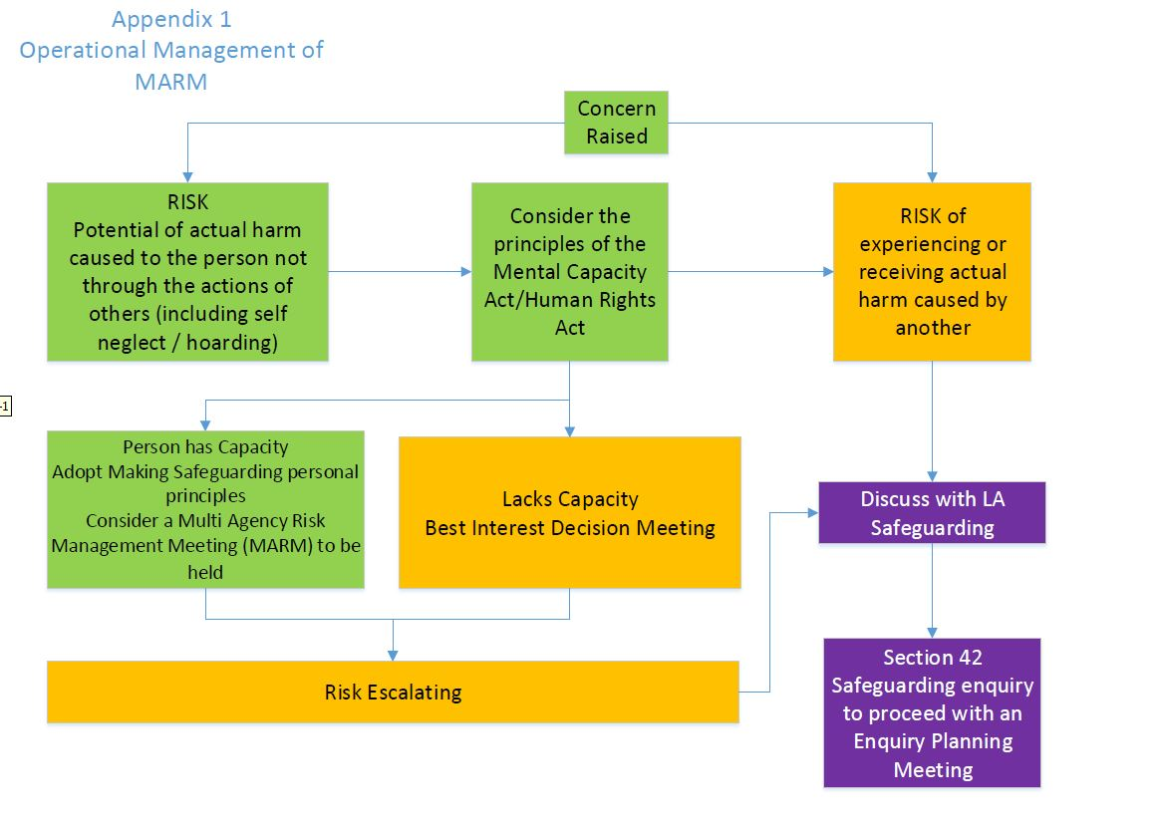

Note: Refer to MARM Guidance for links between MARM and Best Interest meetings

.

